Compare the effectiveness of traditional filters (such as averaging and Gaussian filters) with edge-preserving filters (such as the median filter) in reducing noise while preserving important image features in medical imaging. Discuss scenarios where each type of filter might be preferred, considering factors such as image quality, computational complexity, and impact on diagnostic accuracy. How do these filtering techniques perform in preserving edges and fine details crucial for accurate medical diagnoses?

* **Mean Filters**
* There are a few varieties of mean filters; local mean, percentile mean, bilateral mean….
* With the local mean, all pixels belonging to the filter support are averaged and set to the pixel at the center of the filter. Percentile and usual mean filters yield similar results; they smooth the whole image.
* Image features that are smaller than the kernel size; are strongly reduced, while features much larger than the kernel; are less impacted. The extent of noise reduction depends on the kernel size, with larger kernels providing stronger suppression.
* These filters are sensitive to outliers, if a single pixel can drive the mean value of all the surrounding pixels.
* Particular attention should be paid to edges: edges could be blurred, and this may be an issue if sharp edges are required like in tumor size estimation (Fig. 1).

Fig. 1: In the images above: image (b) is image (a) with Gaussian white noise. Noise is removed in the image (c) with 3 x 3 mean filter; but some blurring occurs [1].

* Gaussian filter
* Gaussian smoothing uses a “point-spread” gaussian distribution to the center of the filter frame: points three standard deviations away are set to zero intensity.
* Once a suitable kernel has been determined, since the kernel is symmetric, a 2-D convolution is performed by first convolving with a 1-D Gaussian in the *x-direction* followed by another convolution with a 1-D Gaussian in the *y direction*.
* The effect of the Gaussian filter is to smooth an image which is proportional to the standard deviation of the Gaussian. In contrast to the mean filter which has a uniform weighted average, the Gaussian filter outputs a gradual average of each pixel’s neighborhood.
* Gaussian filter like the mean filters are lowpass frequency filters which eliminate rapid intensity changes in the image such as noise or fine details.
* This is especially useful for medical images when the goal is to highlight organs or tissues.
* Median filter
* On each center of the kernel frame, pixel (i,j); it computes the median values of all the pixels present within the kernel filter.
* Compared to the average or Gaussian filter; it is less effective in noise removal and images can look less smooth.
* However, edges are not as much filtered by the median filter compared to these two filters; and the median filter is particularly efficient in the removal of specific type of noise; like “pepper-and-salt noise” (Fig. 2).

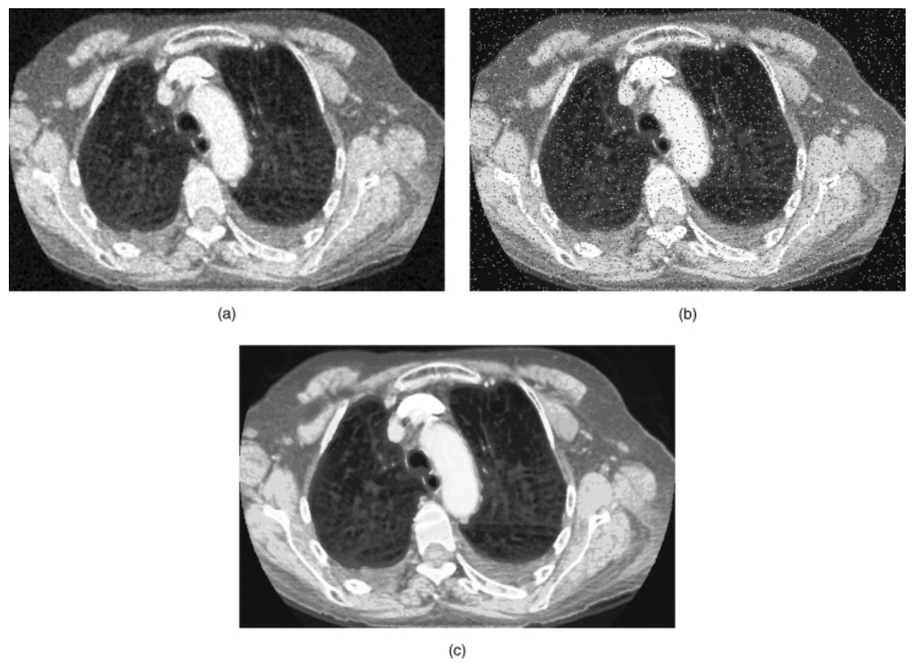

Fig. 2: A 3 x 3 median filter is applied to the same noisy image referenced above with the mean filters; generates image (a); it is less efficient in removing the noise; however, the edges are more preserved. The same filter removes efficiently the “pepper-and-salt noise” added in image (b) and render an image of good quality: image (c) [1].

* Processing Times

The authors of [3] conducted a research of estimating processing time of parallel implementation of mean, median and Gaussian filtering algorithms and concluded that their processing speed were comparable with the greatest increase observed for the median filter.

The median filter also showed the best noise reduction but could suppress details.

Sources

[1]: [Handbook of Medical Image Processing and Analysis (Second Edition)](https://www-sciencedirect-com.proxy1.library.jhu.edu/science/book/9780123739049)

(Paranjaoe, Fudamental Enhancement Techniques, 2009) <https://doi.org/10.1016/B978-012373904-9.50008-8>.

[2]: Image Processing Learning Resource: <https://homepages.inf.ed.ac.uk/rbf/HIPR2/hipr_top.htm>

[3]: Evaluation of Noise Reduction Filters in Medical Image Processing using OpenMP.

Luis Cadena, Darwin Castillo, Aleksandr Zotin, Franklin Cadena, Patricia Diaz. IAENG International Journal of Computer Science, 46:4, IJCS_46_4_09